# Prepare virtual environment

1. Create a virtual environment

$ virtualenv --python=/usr/bin/python3 --no-site-packages tensorrt

1. Activate virtual environment

$ source edsr040/bin/activate

1. Install Pytorch 0.4.0 (After all packages installed)

$ wget <https://download.pytorch.org/whl/cu90/torch-0.4.0-cp35-cp35m-linux_x86_64.whl>

$ pip3 install [torch-0.4.0-cp35-cp35m-linux_x86_64.whl](https://download.pytorch.org/whl/cu90/torch-0.4.0-cp35-cp35m-linux_x86_64.whl)

1. (important:  
   you cannot install Pytorch via conda in virtualenv because conda will not install Pytorch in correct place in virtual environment.  
   Pytorch 1.0.0 support ai.onnx version 9 which is not supported by nGraph. We need to use Pytorch previous version.  
   In my environment, I use python 3.5 and cuda 9.0.)

$ pip install numpy

$ pip install torchvision

$ pip install matplotlib

1. Install onnx 1.3.0

# apt-get install protobuf-compiler libprotoc-dev

# pip install onnx

1. Install jupyter

$ pip install jupyter

1. Install ipython

$ pip install ipython

1. Install packages needed by EDSR

$ pip install imageio

$ pip install tqdm

$ pip install scikit-image

# Baseline Models

Baseline models are placed in ‘./experiment/model’. These models can be downloaded from

<https://cv.snu.ac.kr/research/EDSR/model_pytorch.tar>.

Here we have the models EDSR_x2.pt, EDSR_x3.pt, EDSR_x4.pt and MDSR.pt.

These models are placed in the directory of ‘../experiment/model’.

# Dataset

You can evaluate your models with widely-used benchmark datasets:

* [Set5 - Bevilacqua et al. BMVC 2012]  
  (http://people.rennes.inria.fr/Aline.Roumy/results/SR_BMVC12.html),
* [Set14 - Zeyde et al. LNCS 2010]  
  (https://sites.google.com/site/romanzeyde/research-interests),
* [B100 - Martin et al. ICCV 2001]  
  (https://www2.eecs.berkeley.edu/Research/Projects/CS/vision/bsds/),
* [Urban100 - Huang et al. CVPR 2015]  
  (https://sites.google.com/site/jbhuang0604/publications/struct_sr).

For these datasets, we first convert the result images to YCbCr color space and evaluate PSNR on the Y channel only.

These preprocessed dataset can be downloaded from

<https://cv.snu.ac.kr/research/EDSR/benchmark.tar>.

To use these dataset, we set ‘--dir_data <where_benchmark_folder_located>’ to evaluate the EDSR and MDSR with the benchmarks.

In order to use the dataset of DIV2K, we need to edit src/option.py, modify --dir_data argument as:

parser.add_argument('--dir_data', type=str, default='../../../data',

help='dataset directory')

The parameter ‘../../../data’ is the root directory where DIV2K directory put into. That is the directory of DIV2K is ‘../../../data/DIV2K’.

# Build Models

## NOTICE

We recommend you to pre-process the images before training. This step will decode all **png** files and save them as binaries. Use ‘--ext sep_reset’ argument on your first run. You can skip the decoding part and use saved binaries with ‘--ext sep’` argument. The default value of ‘--ext' is ‘sep'.

## EDSR Baseline x2 (resblocks=16/feats=64)

|  |
| --- |
| python main.py --model EDSR --scale 2 --patch_size 96 --save edsr_baseline_x2 --reset |

Build EDSR baseline x2 model with dataset directory on ‘../../../data’, train/test data on DIV2K with the data range of 1-700/701-800 respectively.

The built model is placed in ‘../experiment/edsr_baseline_x2/model/model_best.pt’

### PSNR & L1 Loss

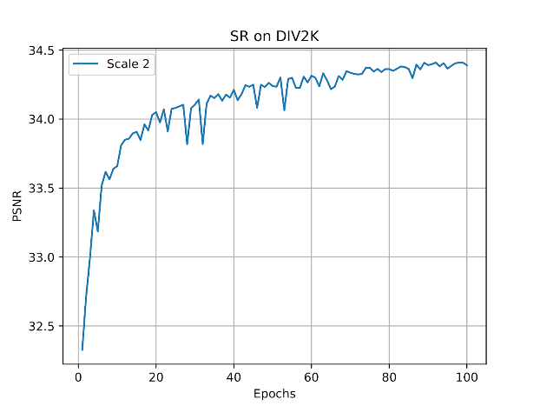

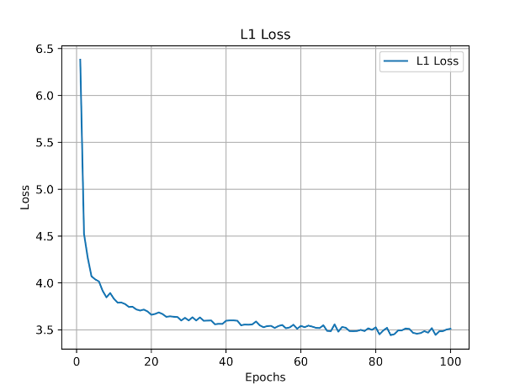

### Evaluation

|  |
| --- |
| python main.py --data_test Demo --scale 2 --pre_train '../experiment/edsr_baseline_x2/model/model_best.pt' --test_only --save_results  Forward: 0.52s (GPU) |

|  |
| --- |
| python main.py --data_test Demo --cpu --scale 2 --pre_train '../experiment/edsr_baseline_x2/model/model_best.pt' --test_only --save_results  Forward: 22.99s (CPU) |

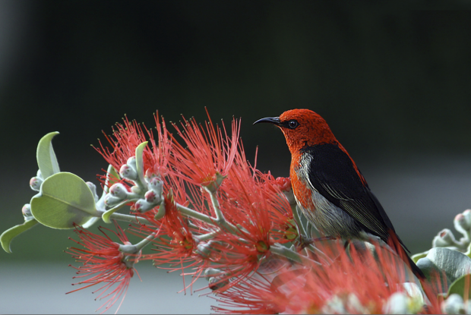

## EDSR Baseline x3 (resblocks=16/feats=64)

|  |
| --- |
| python main.py --model EDSR --scale 3 --patch_size 144 --save edsr_baseline_x3 --epochs 100 --lr 1e-4 --decay 20-45-60-80 --reset --pre_train '../experiment/edsr_baseline_x2/model/model_best.pt' |

Build EDSR baseline x3 model from EDSR baseline model x2 with dataset directory on ‘../../../data’, train/test data on DIV2K with the data range of 1-700/701-800 respectively.

The built model is placed in ‘../experiment/edsr_baseline_x3/model/model_best.pt’

### PSNR & L1 Loss

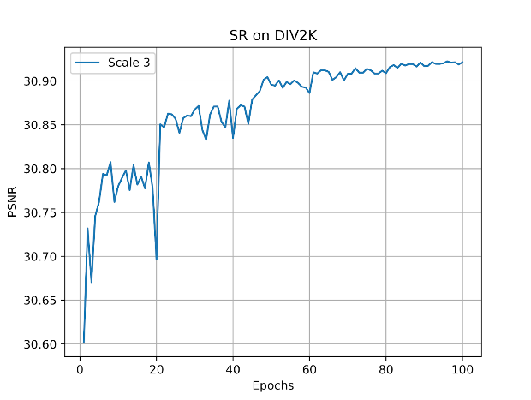

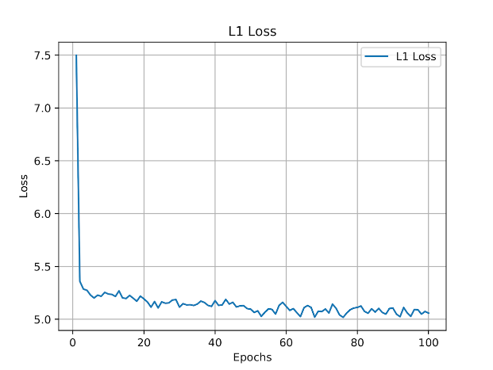

### Evaluation

|  |
| --- |
| python main.py --data_test Demo --scale 3 --pre_train '../experiment/edsr_baseline_x3/model/model_best.pt' --test_only --save_results  Forward: 0.55s (GPU) |

|  |
| --- |
| python main.py --data_test Demo --cpu --scale 3 --pre_train '../experiment/edsr_baseline_x3/model/model_best.pt' --test_only --save_results  Forward: 25.83s (CPU) |

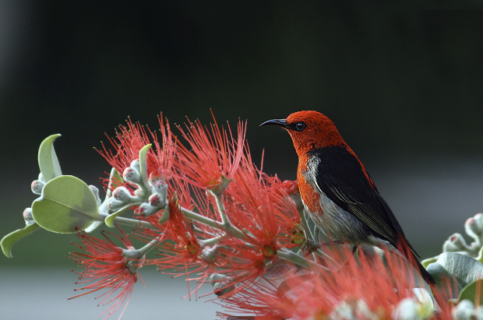

## EDSR Baseline x4

|  |
| --- |
| python main.py --model EDSR --scale 4 --save edsr_baseline_x4 --reset --pre_train '../experiment/edsr_baseline_x2/model/model_best.pt' |

Build EDSR baseline x4 model from EDSR baseline model x2 with dataset directory on ‘../../../data’, train/test data on DIV2K with the data range of 1-700/701-800 respectively.

The built model is placed in ‘../experiment/edsr_baseline_x4/model/model_best.pt’

## EDSR x2 (resblocks=24/feats=64)

|  |
| --- |
| python main.py --model EDSR --scale 2 --save edsr_x2 --n_GPUs 1 --n_resblocks 24 --n_feats 64 --batch_size 16 --res_scale 0.1 --epochs 100 --lr 1e-4 --decay 20-45-60-80 --ext bin --reset |

Build EDSR in the paper x2 model with dataset directory on ‘../../../data’, train/test data on DIV2K with the data range of 1-700/701-800 respectively.

The built model is placed in ‘../experiment/edsr_x2/model/model_best.pt’

### PSNR & L1 Loss

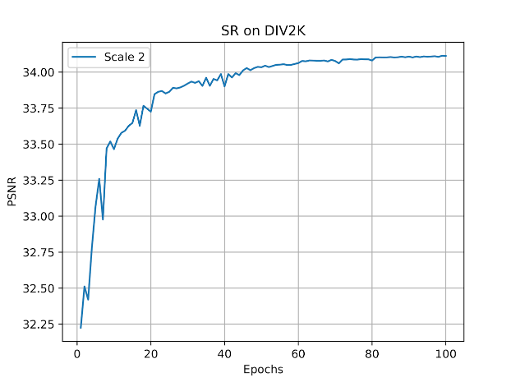

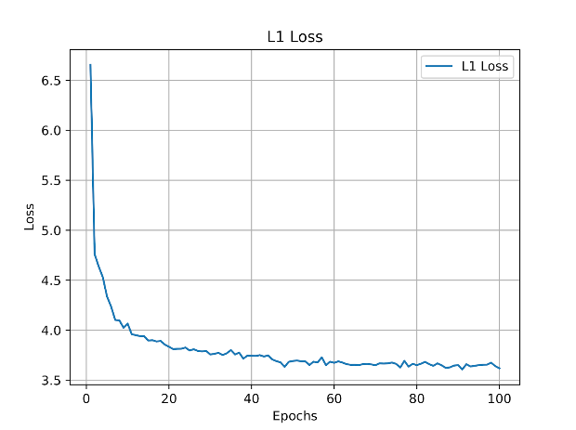

### Evaluation

|  |
| --- |
| python main.py --data_test Demo --scale 2 --n_resblocks 24 --n_feats 64 --batch_size 16 --res_scale 0.1 --pre_train '../experiment/edsr_x2/model/model_best.pt' --test_only --save_results  Forward: 0.58s (GPU) |

|  |
| --- |
| python main.py --data_test Demo --cpu --scale 2 --n_resblocks 24 --n_feats 64 --batch_size 16 --res_scale 0.1 --pre_train '../experiment/edsr_x2/model/model_best.pt' --test_only --save_results  Forward: 30.10s (CPU) |

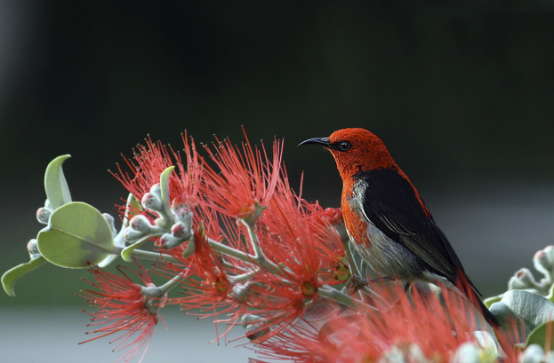

## EDSR x3 (resblocks=24/feats=64)

|  |
| --- |
| python main.py --model EDSR --scale 3 --save edsr_x3 --n_GPUs 1 --n_resblocks 24 --n_feats 64 --batch_size 16 --res_scale 0.1 --epochs 100 --lr 1e-4 --decay 20-45-60-80 --ext bin --reset --pre_train '../experiment/edsr_x2/model/model_best.pt' |

Build EDSR in the paper x3 model from EDSR in the paper x2 model with dataset directory on ‘../../../data’, train/test data on DIV2K with the data range of 1-700/701-800 respectively.

The built model is placed in ‘../experiment/edsr_x3/model/model_best.pt’

### PSNR & L1 Loss

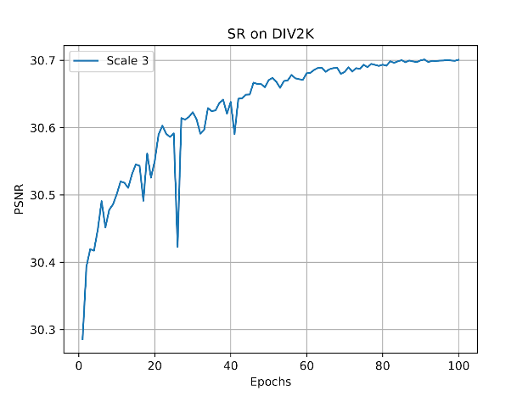

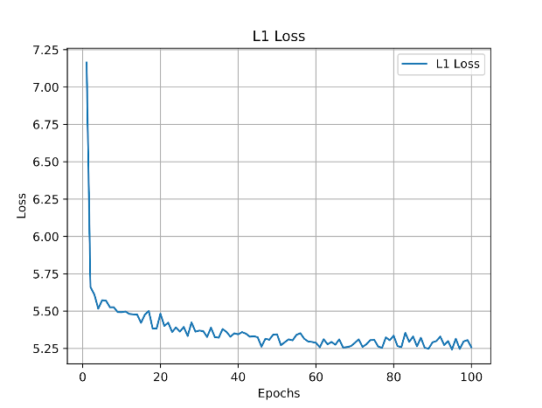

### Evaluation

|  |
| --- |
| python main.py --data_test Demo --scale 3 --n_resblocks 24 --n_feats 64 --batch_size 16 --res_scale 0.1 --pre_train '../experiment/edsr_x3/model/model_best.pt' --test_only --save_results  Forward: 0.57s (GPU) |

|  |
| --- |
| python main.py --data_test Demo --cpu --scale 3 --n_resblocks 24 --n_feats 64 --batch_size 16 --res_scale 0.1 --pre_train '../experiment/edsr_x3/model/model_best.pt' --test_only --save_results  Forward: 33.81s (CPU) |

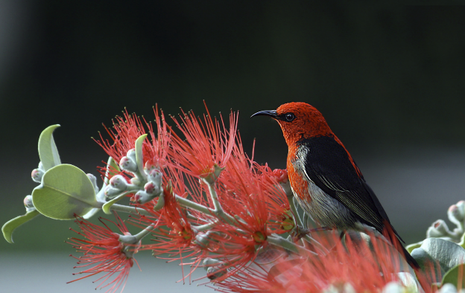

# Standard Benchmarks

## Dataset

Dataset directory:

* Set5: ../../../data/benchmark/Set5  
  dir_hr: ../../../data/benchmark/Set5/HR, dir_lr: ../../../data/benchmark/Set5/LR_bicubic
* Set14: ../../../data/benchmark/Set14  
  dir_hr: ../../../data/benchmark/Set14/HR, dir_lr: ../../../data/benchmark/Set14/LR_bicubic
* B100: ../../../data/benchmark/B100  
  dir_hr: ../../../data/benchmark/B100/HR, dir_lr: ../../../data/benchmark/B100/LR_bicubic
* Urban100: ../../../data/benchmark/Urban100  
  dir_hr: ../../../data/benchmark/Urban100/HR, dir_lr: ../../../data/benchmark/Urban100/LR_bicubic
* DIV2K: ../../../data  
  hr_dir=../../../data/DIV2K/DIV2K_train_HR, lr_dir=../../../data/DIV2K/DIV2K_train_LR_bicubic

## EDSR_baseline_x2 (resblocks=16/feats=64)

|  |
| --- |
| python main.py --data_test Set5+Set14+B100+Urban100+DIV2K --data_range 701-800 --scale 2 --pre_train '../experiment/edsr_baseline_x2/model/model_best.pt' --test_only --save_results |

[Set5 x2] PSNR: 37.802

[Set14 x2] PSNR: 33.360

[B100 x2] PSNR: 32.040

[Urban100 x2] PSNR: 31.463

[DIV2K x2] PSNR: 34.410

Forward: 62.03s (GPU)

|  |
| --- |
| python main.py --data_test Set5+Set14+B100+Urban100+DIV2K --data_range 701-800 --scale 2 --cpu --pre_train '../experiment/edsr_baseline_x2/model/model_best.pt' --test_only --save_results |

[Set5 x2] PSNR: 37.802

[Set14 x2] PSNR: 33.360

[B100 x2] PSNR: 32.040

[Urban100 x2] PSNR: 31.463

[DIV2K x2] PSNR: 34.410

Forward: 6486.61s (CPU)

|  |
| --- |
| python main.py --data_test Set5+Set14+B100+Urban100+DIV2K --data_range 701-800 --scale 2 --pre_train '../experiment/edsr_baseline_x2/model/model_best.pt' --test_only --save_results --self_ensemble |

[Set5 x2] PSNR: 37.928

[Set14 x2] PSNR: 33.473

[B100 x2] PSNR: 32.105

[Urban100 x2] PSNR: 31.664

[DIV2K x2] PSNR: 34.513

Forward: 491.67s (GPU)

## EDSR_baseline_x3 (resblocks=16/feats=64)

|  |
| --- |
| python main.py --data_test Set5+Set14+B100+Urban100+DIV2K --data_range 701-800 --scale 3 --pre_train '../experiment/edsr_baseline_x3/model/model_best.pt' --test_only --save_results |

[Set5 x3] PSNR: 34.263

[Set14 x3] PSNR: 30.232

[B100 x3] PSNR: 29.035

[Urban100 x3] PSNR: 27.917

[DIV2K x3] PSNR: 30.922

Forward: 36.68s (GPU)

|  |
| --- |
| python main.py --data_test Set5+Set14+B100+Urban100+DIV2K --data_range 701-800 --scale 3 --cpu --pre_train '../experiment/edsr_baseline_x3/model/model_best.pt' --test_only --save_results |

[Set5 x3] PSNR: 34.263

[Set14 x3] PSNR: 30.232

[B100 x3] PSNR: 29.035

[Urban100 x3] PSNR: 27.917

[DIV2K x3] PSNR: 30.922

Forward: 3245.74s (CPU)

|  |
| --- |
| python main.py --data_test Set5+Set14+B100+Urban100+DIV2K --data_range 701-800 --scale 3 --pre_train '../experiment/edsr_baseline_x3/model/model_best.pt' --test_only --save_results --self_ensemble |

[Set5 x3] PSNR: 34.393

[Set14 x3] PSNR: 30.326

[B100 x3] PSNR: 29.090

[Urban100 x3] PSNR: 28.038

[DIV2K x3] PSNR: 31.001

Forward: 289.41s (GPU)

## EDSR_baseline_x4 (resblocks=16/feats=64)

|  |
| --- |
| python main.py --data_test Set5+Set14+B100+Urban100+DIV2K --data_range 701-800 --scale 4 --res_scale 0.1 --pre_train download --test_only --save_results --ext sep |

[Set5 x4] PSNR: 29.077

[Set14 x4] PSNR: 26.575

[B100 x4] PSNR: 26.321

[Urban100 x4] PSNR: 23.594

[DIV2K x4] PSNR: 27.495

Forward: 29.72s (GPU)

|  |
| --- |
| cpu |

[Set5 x4] PSNR: 32.484

[Set14 x4] PSNR: 28.815

[B100 x4] PSNR: 27.721

[Urban100 x4] PSNR: 26.645

|  |
| --- |
| --self_ensemble |

[Set5 x4] PSNR: 32.643

[Set14 x4] PSNR: 28.952

[B100 x4] PSNR: 27.799

[Urban100 x4] PSNR: 26.867

## EDSR x2 (resblocks=16/feats=80)

|  |
| --- |
| python main.py --data_test Set5+Set14+B100+Urban100+DIV2K --data_range 701-800 --scale 2 --n_resblocks 16 --n_feats 80 --batch_size 16 --res_scale 0.1 --pre_train '../experiment/edsr_x2/model/model_best.pt' --test_only --save_results |

[Set5 x2] PSNR: 37.536

[Set14 x2] PSNR: 33.113

[B100 x2] PSNR: 31.858

[Urban100 x2] PSNR: 30.828

[DIV2K x2] PSNR: 34.116

Forward: 228.39s (GPU)

## EDSR x2 (resblocks=24/feats=64)

|  |
| --- |
| python main.py --data_test Set5+Set14+B100+Urban100+DIV2K --data_range 701-800 --scale 2 --n_resblocks 24 --n_feats 64 --batch_size 16 --res_scale 0.1 --pre_train '../experiment/edsr_x2/model/model_best.pt' --test_only --save_results |

[Set5 x2] PSNR: 37.538

[Set14 x2] PSNR: 33.119

[B100 x2] PSNR: 31.859

[Urban100 x2] PSNR: 30.863

[DIV2K x2] PSNR: 34.114

Forward: 87.58s (GPU)

|  |
| --- |
| python main.py --data_test Set5+Set14+B100+Urban100+DIV2K --data_range 701-800 --scale 2 --cpu --n_resblocks 24 --n_feats 64 --batch_size 16 --res_scale 0.1 --pre_train '../experiment/edsr_x2/model/model_best.pt' --test_only --save_results |

[Set5 x2] PSNR: 37.538

[Set14 x2] PSNR: 33.119

[B100 x2] PSNR: 31.859

[Urban100 x2] PSNR: 30.863

[DIV2K x2] PSNR: 34.114

Forward: 9122.92s

|  |
| --- |
| python main.py --data_test Set5+Set14+B100+Urban100+DIV2K --data_range 701-800 --scale 2 --n_resblocks 24 --n_feats 64 --batch_size 16 --res_scale 0.1 --pre_train '../experiment/edsr_x2/model/model_best.pt' --test_only --save_results --self_ensemble |

[Set5 x2] PSNR: 37.617

[Set14 x2] PSNR: 33.162

[B100 x2] PSNR: 31.893

[Urban100 x2] PSNR: 30.923

[DIV2K x2] PSNR: 34.163

Forward: 709.86s (GPU)

## EDSR x3 (resblocks=24/feats=64)

|  |
| --- |
| python main.py --data_test Set5+Set14+B100+Urban100+DIV2K --data_range 701-800 --scale 3 --n_resblocks 24 --n_feats 64 --batch_size 16 --res_scale 0.1 --pre_train '../experiment/edsr_x3/model/model_best.pt' --test_only --save_results |

[Set5 x3] PSNR: 33.942

[Set14 x3] PSNR: 30.043

[B100 x3] PSNR: 28.896

[Urban100 x3] PSNR: 27.412

[DIV2K x3] PSNR: 30.701

Forward: 47.84s (GPU)

|  |
| --- |
| python main.py --data_test Set5+Set14+B100+Urban100+DIV2K --data_range 701-800 --scale 3--cpu --n_resblocks 24 --n_feats 64 --batch_size 16 --res_scale 0.1 --pre_train '../experiment/edsr_x3/model/model_best.pt' --test_only --save_results |

[Set5 x3] PSNR: 33.942

[Set14 x3] PSNR: 30.043

[B100 x3] PSNR: 28.896

[Urban100 x3] PSNR: 27.412

[DIV2K x3] PSNR: 30.701

Forward: 4441.33s

|  |
| --- |
| python main.py --data_test Set5+Set14+B100+Urban100+DIV2K --data_range 701-800 --scale 3 --n_resblocks 24 --n_feats 64 --batch_size 16 --res_scale 0.1 --pre_train '../experiment/edsr_x3/model/model_best.pt' --test_only --save_results --self_ensemble |

[Set5 x3] PSNR: 34.063

[Set14 x3] PSNR: 30.107

[B100 x3] PSNR: 28.932

[Urban100 x3] PSNR: 27.480

[DIV2K x3 PSNR: 30.752

Forward: 384.35s (GPU)

## MDSR

|  |
| --- |
| python main.py --model MDSR --data_test Set5+Set14+B100+Urban100+DIV2K --data_range 701-800 --scale 2+3+4 --pre_train download --test_only --save_results |

[Set5 x2] PSNR: 37.976 (Best: 37.976 @epoch 1)

[Set5 x3] PSNR: 34.367 (Best: 34.367 @epoch 1)

[Set5 x4] PSNR: 32.161 (Best: 32.161 @epoch 1)

[Set14 x2] PSNR: 33.580 (Best: 33.580 @epoch 1)

[Set14 x3] PSNR: 30.332 (Best: 30.332 @epoch 1)

[Set14 x4] PSNR: 28.598 (Best: 28.598 @epoch 1)

[B100 x2] PSNR: 32.167 (Best: 32.167 @epoch 1)

[B100 x3] PSNR: 29.090 (Best: 29.090 @epoch 1)

[B100 x4] PSNR: 27.576 (Best: 27.576 @epoch 1)

[Urban100 x2] PSNR: 32.086 (Best: 32.086 @epoch 1)

[Urban100 x3] PSNR: 28.156 (Best: 28.156 @epoch 1)

[Urban100 x4] PSNR: 26.067 (Best: 26.067 @epoch 1)

[DIV2K x2] PSNR: 34.704 (Best: 34.704 @epoch 1)

[DIV2K x3] PSNR: 31.078 (Best: 31.078 @epoch 1)

[DIV2K x4] PSNR: 29.190 (Best: 29.190 @epoch 1)

Forward: 207.73s (GPU)

# Super Resolution Result

## X2 Original picture



## X2 Inferrenced picture (EDSR)



## X2 Inferrenced picture (MDSR)



## X3 Original picture



## X3 Inferrenced picture (EDSR)



## X3 Inferrenced picture (MDSR)



## X4 Original picture



## X4 Inferrenced picture (EDSR)



## X4 Inferrenced picture (MDSR)



# Enhancement

## Usage

1. source lab5-venv/bin/activate
2. Put valid data into

./benchmark/valid

./benchmark/valid/HR

./benchmark/valid/LR_bicubic

1. cd edsr040/EDSR-PyTorch/src

## Usage (in aitrain.nchc.org.tw)

1. Prepare environment:

(for reshape reason, I need torch 0.4.0)

cd /home/dllab/ngraph

source ~/ngraph/onnx/bin/activate

pip install --upgrade pip

pip3 install --force-reinstall torch==0.4.0

cd ~/TensorRT-5.0.2.6/python

pip3 install tensorrt-5.0.2.6-py2.py3-none-any.whl

pip install matplotlib

pip install imageio

pip install tqdm

pip install scikit-image

cd /tmp/work/chilung/sr/EDSR-PyTorch/src

python edsr_main.py --dir_data './' --data_test valid --scale 2 --pre_train './edsr_baseline_download.pt' --test_only

1. Start execution:

cd /home/dllab/ngraph

source ~/ngraph/onnx/bin/activate

cd /tmp/work/chilung/sr/EDSR-PyTorch/src

python edsr_main.py --dir_data './' --data_test valid --scale 2 --pre_train './edsr_baseline_download.pt' --test_only

1. Annoying Situation

Hang up again and again CPU inference:

1. How about Original EDSR

**(X) CASE a:**

pip3 install --force-reinstall torch==0.4.0

cd /tmp/work/chilung/org_edsr/EDSR-PyTorch/src

python main.py --dir_data './' --data_test Set5 --scale 2 --pre_train './edsr_baseline_download.pt' --test_only --cpu

RESULT:

1. hang up after inference just 2 images
2. hang up after inference just 9 images

**CASE b:**

pip3 install --force-reinstall torch==0.4.1

cd /tmp/work/chilung/org_edsr/EDSR-PyTorch/src

python main.py --dir_data './' --data_test Set5 --scale 2 --pre_train './edsr_baseline_download.pt' --test_only --cpu

RESULT:

1. hang up after inference just 9 images
2. How about stand alone ngraph

**CASE c:**

As prepare environment 0.4.1 fail for onnx not support dynamic reshape.

**CASE d:**

As prepare environment 0.4.0

RESULT:

1. pass for inferencing 10 images (224x224)
2. pass for inferencing 100 images (224x224)
3. lr.to.cuda: pass for inferencing 100 images (224x224)
4. lr.to.cuda: fail for just inferencing 1 images (1024x1024)
5. EDSR ngraph (As prepare environment 0.4.0)

**CASE e:**

RESULT:

1. fail for just inferencing 2 valid dataset images
2. fail for just inferencing 2 valid dataset images
3. Original EDSR 1.0.0 with Pytorch 1.0.0

**CASE f:**

git clone <https://github.com/thstkdgus35/EDSR-PyTorch.git>

pip install torch==1.0.0

cd /tmp/work/chilung/edsr100/EDSR-PyTorch/src

RESULT:

1. fail for just inferencing 2 valid dataset images

**CASE g:**

EDSR sr/, torch==0.4.1

Test dataset Urban100

RESULT:

1. pass for inferencing 100 Urban100 dataset images
2. pin_memory = False, move import out of loop

**CASE g:**

RESULT:

fail for just inferencing 1 valid dataset images

1. stand alone ngraph with inference only w/ dynamic convert pytorch to ngraph

**CASE h:**

Tt.py

1024x1024

RESULT:

fail for just inferencing 1 valid dataset images

1. Try to rebuild onnx/ngraph environment

**CASE i:**

RESULT:

crash while $ python3 setup.py bdist_wheel

1. Memory Usage:

Check memory limit:

$ cat /sys/fs/cgroup/memory/memory.limit_in_bytes

10,737,418,240

Check memory Usage:

$ cat /sys/fs/cgroup/memory/memory.usage_in_bytes

**Fail on Pytorch - nGraph model to inference valid dataset at 5 images**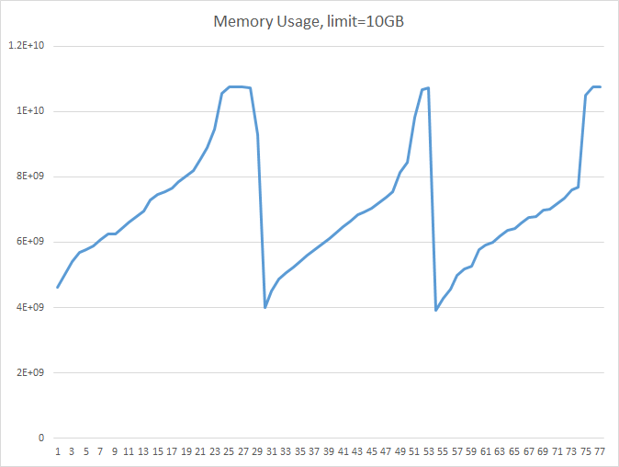

1. Memory Usage:

**Complete Pytorch - nGraph model to inference 100 dummy input dataset for 512x521 to 1024x1024**

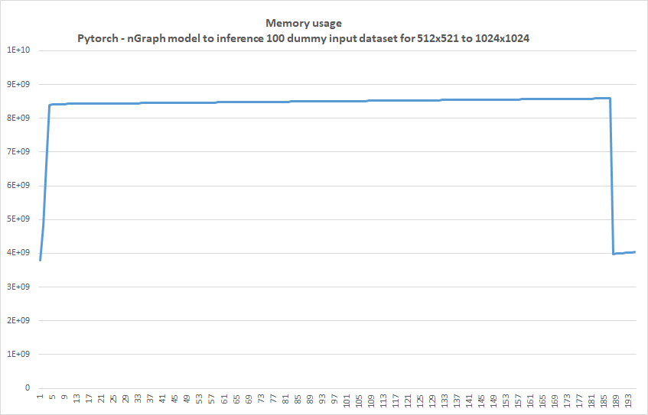

1. Memory Usage:

**Original EDSR cpu inference for valid dataset**

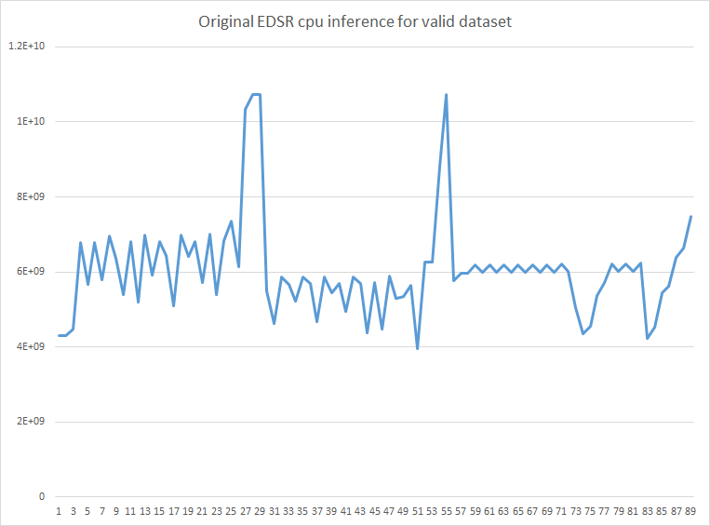

## GPU inference - download pretrained model

|  |
| --- |
| python edsr_main.py --dir_data './' --data_test valid --scale 2 --pre_train download --test_only --save_results  python edsr_main.py --dir_data './' --data_test valid --scale 2 --pre_train './edsr_baseline_download.pt' --test_only --save_results |

Making model...

Download the model

Downloading: "https://cv.snu.ac.kr/research/EDSR/models/edsr_baseline_x2-1bc95232.pt" to ../models/edsr_baseline_x2-1bc95232.pt

Evaluation:

[valid x2] PSNR: 36.132 (Best: 36.132 @epoch 1)

Forward: 45.00s

## GPU inference - retrain model

|  |
| --- |
| python edsr_main.py --dir_data './' --data_test valid --scale 2 --pre_train './edsr_baseline_retrain.pt' --test_only --save_results |

Test Set: valid

Making model...

Load the model from ../experiment/edsr_baseline_x2-1202/model/model_best.pt

Evaluation:

[valid x2] PSNR: 35.861 (Best: 35.861 @epoch 1)

Forward: 45.85s

## CPU inference - Pytorch → nGraph model

### Get full model

|  |
| --- |
| python edsr_main.py --dir_data './' --data_test valid --scale 2 --pre_train './edsr_baseline_download.pt' --test_only --resave_full_model 'edsr.model' |

In **option.py**

Add code:

*parser.add_argument('--resave_full_model', type=str, default='',*

*help='resave a full model')*

In **model/__init__.py**

Add code:

class Model(nn.Module):

def __init__(self, args, ckp):

...

*self.resave_full_model = args.resave_full_model*

def load(self, apath, pre_train='', resume=-1, cpu=False):

…

*if self.resave_full_model: torch.save(self.get_model(), self.resave_full_model)*

### Dynamically Convert to nGraph model according to image size

def test(self):

...

*if self.args.ngraph:*

*pytorch_model_name = self.args.ngraph*

*pytorch_edsr_model = torch.load(pytorch_model_name)*

*# print(lr.size())*

*dummy_input = torch.randn_like(lr, device='cuda')*

*edsr_onnx_filename = '{}.onnx'.format(pytorch_model_name)*

*# print('Export to onnx model {}'.format(edsr_onnx_filename))*

*torch.onnx.export(pytorch_edsr_model, dummy_input, edsr_onnx_filename, export_params=True, verbose=False, training=False)*

*import os*

*import onnx*

*edsr_onnx_model = onnx.load(edsr_onnx_filename)*

*# print(onnx.helper.printable_graph(edsr_onnx_model.graph))*

*from ngraph_onnx.onnx_importer.importer import import_onnx_model*

*ng_models = import_onnx_model(edsr_onnx_model)*

*# print('Convert to nGreph Model')*

*import ngraph as ng*

*ng_model = ng_models[0]*

*runtime = ng.runtime(backend_name='CPU')*

*edsr_ng_model = runtime.computation(ng_model['output'], *ng_model['inputs'])*

*sr = edsr_ng_model(lr, idx_scale)*

*sr = torch.from_numpy(sr)*

*else:*

sr = self.model(lr, idx_scale)

### Perform nGraph cpu inference

|  |
| --- |
| python edsr_main.py --dir_data './' --data_test valid --scale 2 --cpu --ngraph 'edsr.model' --test_only --save_results |

Test Set: valid

Making model...

Evaluation:

[valid x2] PSNR: 36.132 (Best: 36.132 @epoch 1)

Forward: 956.55s

### Inference Metrics

In my machine

Run python inference.py

GPU:

[('psnr', 36.132), ('time', 42.77), ('device', 'cuda'), ('model size', 5,490,680)]

CPU:

[('psnr', 36.132), ('time', 710.89), ('device', 'cpu'), ('model size', 5,515,268)]

### Not Ready

python3 compress_classifier.py --resume=../../../../edsr040/EDSR-PyTorch/src/edsr.model -a edsr_baseline_x2 ../../../../edsr040/EDSR-PyTorch/src/benchmark/valid/LR_bicubic/X2 -j 12 --sense=element

Skimage conflict with numpy 1.16.0rc1,

/home/ccma/n1p1/home/ccma/Chilung/tensorr/lib/python3.5/site-packages/skimage/util# vim arraycrop.py

# from numpy.lib.arraypad import _validate_lengths

from numpy.lib.arraypad import _as_pairs